Student ID: 103585238

Name: Huynh Qui Dang

<https://github.com/quidang/Database_Challenge.git> (REPO FOR DATABASE CHALLENGE)

# Setup Screenshot

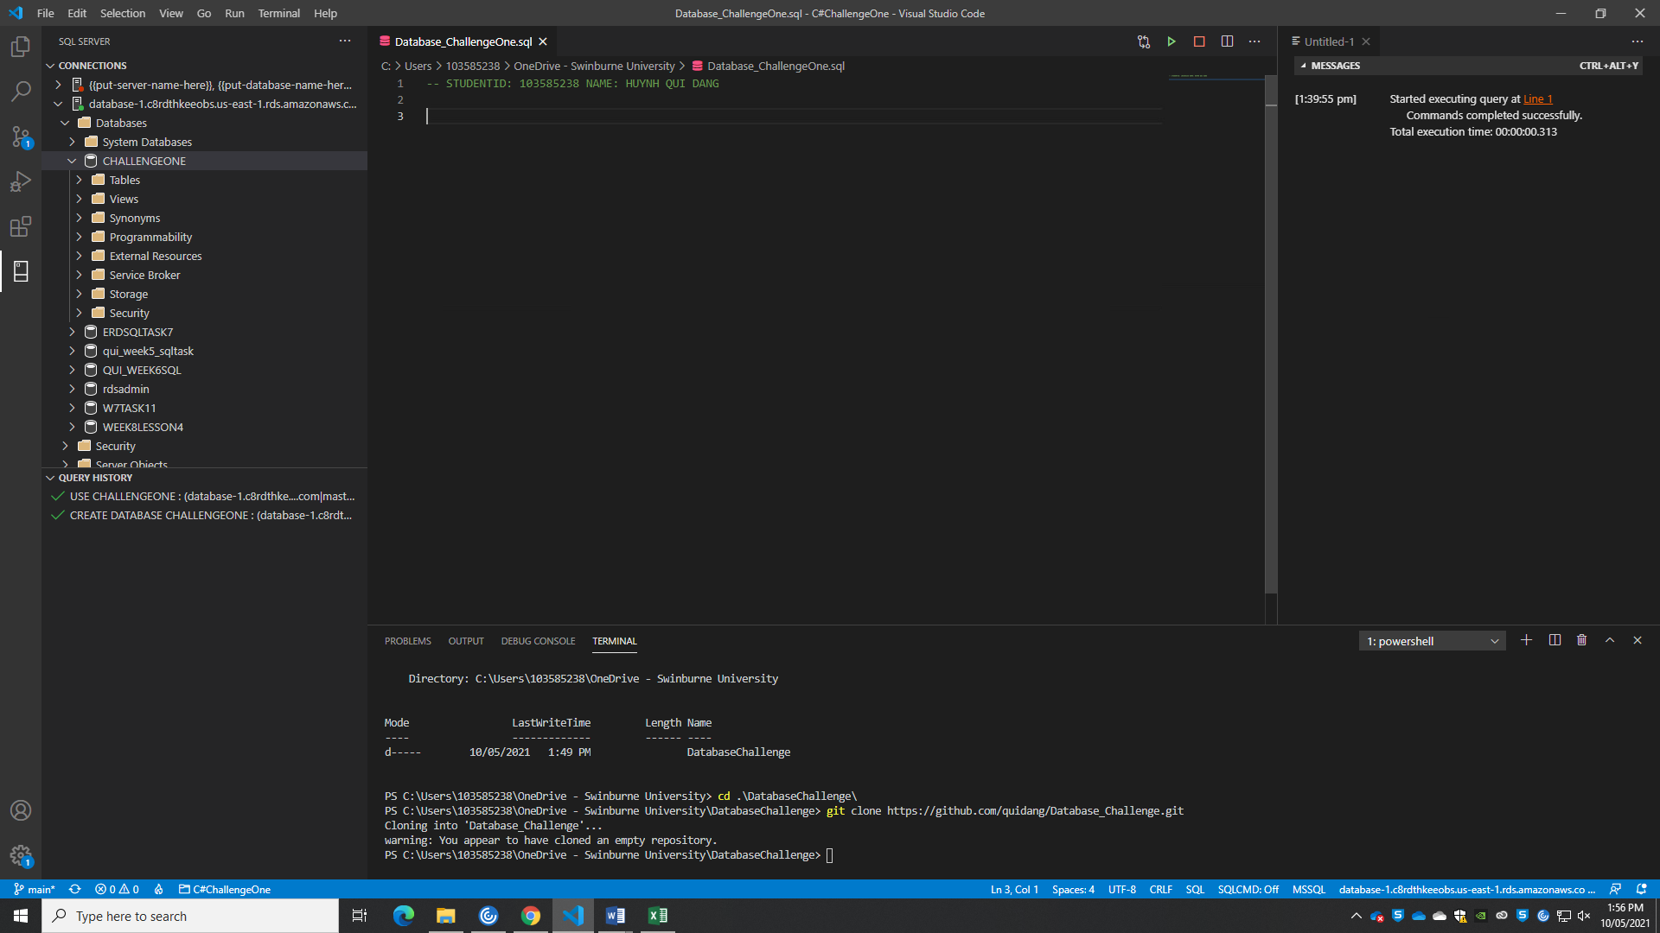

# Task 1 Screenshot

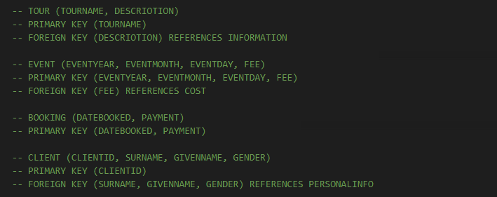

# Task 2 Screenshot

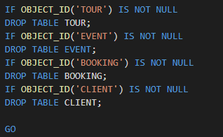

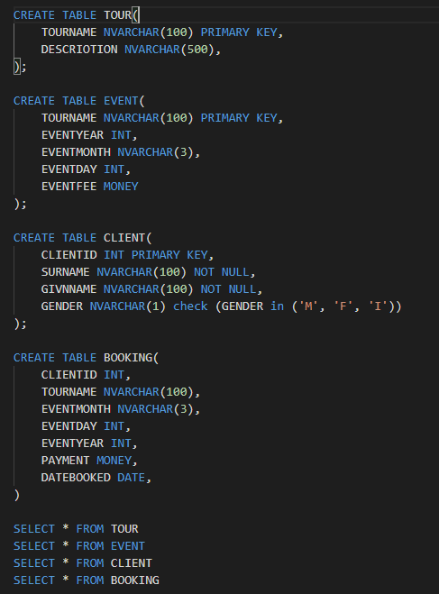

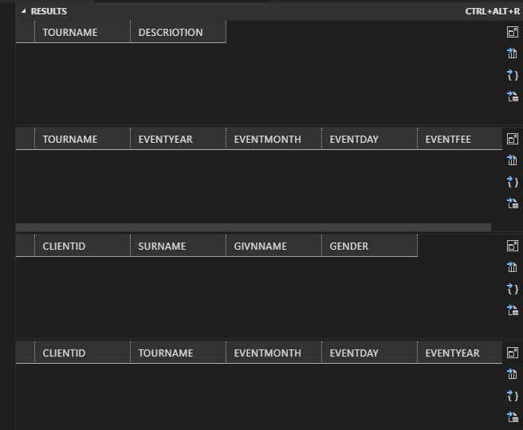

# Task 3 Screenshot

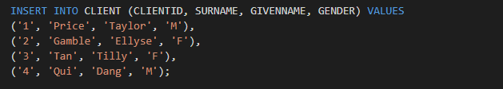

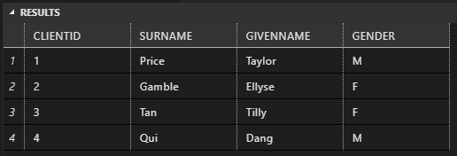

# Task 4 Screenshot

Query 1:



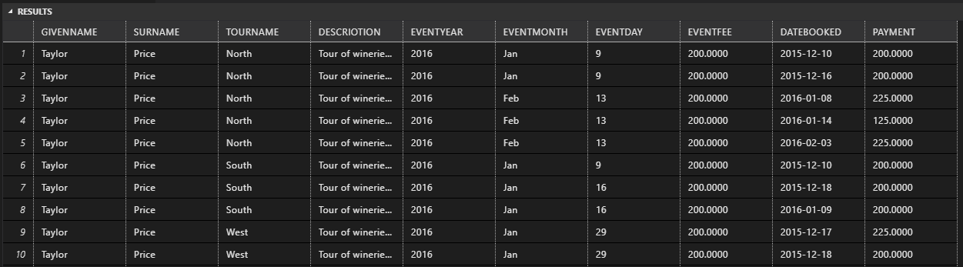

Query 2:

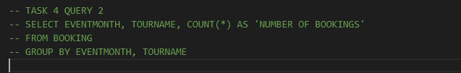 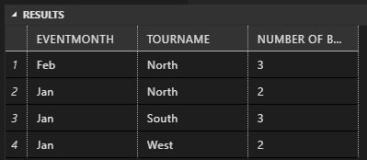

Query 3:

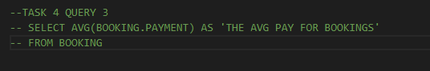

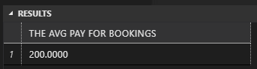

# Task 5 Screenshot

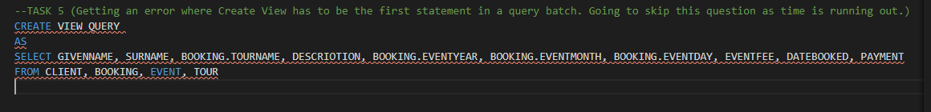

# Task 6 Screenshot

